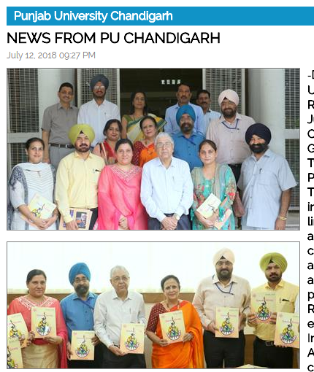
Chandigarh July 12, 2018
Prof. Arun K. Grover, Vice Chancellor (VC), Panjab University, Chandigarh launched the 5th Edition of ‘Jawan Tarang’, an annual magazine of the Department of Youth Welfare, here today.
In his inaugural address, the VC appreciated the efforts of the Department for the uninterrupted publication of the magazine from last five years. He added that the magazine is a part of the attempt todevelop the creative skills of the students as it works as a unique platform for young writers where they can express their thoughts and share their experiences in the society. He also appreciated the contribution of
students from affiliated colleges, constitute colleges and department of the University.
The VC informed that during the later part of this month there will be a
function at Vigyan Bhawan, New Delhi where PU will be giving presentation on Innovative Practices in the recent years at PU. He added that efforts be made by Youth Welfare & Sports Department of PU to highlight their achievements in this presentation. He stressed that large number of academic events taking place in the University facilitate the exposure to frontiers of knowledge in every subject and the same gets disseminated to a larger section of the society. He urged to enhance the
participation of colleges in various events of University.
Dr. Neena Seth Pajni, Editor of the Magazine while expressing her gratitude to the VC in facilitating the publication of the Magazine. She said that this Magazine is a creative and innovative compilation of various events during the year. She added that it is a mirror of youth activities.
Prof. Nishtha Jaswal, officiating Dean of University Instruction, Prof. Amrik Singh Ahluwalia, Secretary to Vice Chancellor, Col. G.S. Chadha, Registrar, Prof. Parvinder Singh, Controller of Examination, Prof. Emanual Nahar, Dean Student Welfare, Prof. Ashwani Koul, Chief of University Security, Prof. Parminder Singh, Directorate of Sports, Prof. Navdeep Sharma, NSS, Sh. Jatinder Moudgil, Manager Press and
representatives of various colleges were present during the occasion.

